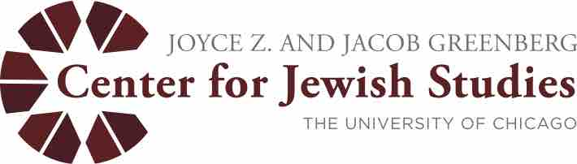
Greenberg Center for Jewish Studies
Dissertation Fellowships 2018-19

The Greenberg Center for Jewish Studies is pleased to announce a competition for one-year dissertation completion fellowships for students in all Divisions and Schools at the University of Chicago pursuing projects on any topic relating to Jewish Studies, including (but not restricted to) study of the history, culture, and thought of the Jews, classical and modern Jewish texts, and languages of the Jews (e.g., biblical through modern Hebrew, Yiddish).

Terms: A Dissertation Year Fellow will receive tuition, the student life fee, a stipend of $24,000, and University Student Health Insurance, if the student elects to take it.

Eligibility: Students must have been formally admitted to candidacy at the time of application (i.e., by April 11, 2018). This deadline is firm and no exceptions will be granted. Dissertation Completion Fellowships may not be held by students who are beyond the eighth year in their programs, and strong preference will be given to applicants currently in year five or year six of their programs.

Application process: Applicants should submit a letter of application electronically as a Word or PDF attachment to Nancy Pardee at npardee@uchicago.edu. Applicants must also provide the following supporting documents:

1) letters of recommendation from all members of the applicant’s dissertation committee
2) an electronic copy of the applicant’s dissertation proposal
3) an electronic copy of the table of contents and current completion status of each chapter
4) an electronic copy of the applicant’s curriculum vitae (CV)
5) an electronic copy of one (and no more than one) completed chapter of the applicant’s dissertation
6) a copy of the applicant’s official transcript
7) a list of all competitive fellowships, in and outside of the University of Chicago, to which the applicant has applied for 2018-19

The confidential letters of recommendation may be sent by the faculty members directly to the Center by regular mail, interoffice mail, or email, or presented by the applicant in sealed envelopes bearing the signature of the faculty member across the seal. The Center Governing Board reserves the right to exclude from consideration application dossiers that do not comply with these requirements.

All application materials must be received by 4 p.m. on Wednesday, April 11, 2018. Late materials cannot be accepted. For further information, contact Nancy Pardee, npardee@uchicago.edu or 773-702-7108.

